***NAME :- S.VIDYA SAGAR***

***REG.NO : RA2111003010969***

***SECTION : D2***

***PPS MINI PROJECT***

***CALCULATING ELECTRICITY BILL THROUGH C PROGRAMMING***

#include <stdio.h>

int main(){

int units;

float amount,charge,total_amount;

//Asking for inputs

printf("Enter total no.of units consumed :- ");

scanf("%d",&units);

//Calculating electricity bill---

if(0<units<50){

amount= units*1.50;

charge = 30;

}

else if(50<units<100){

amount = units*2.00;

charge = 50;

}

else if(100<units<150){

amount = units*2.50;

charge = 70;

}

else if(150<units<200){

amount = units*3.00;

charge = 100;

}

else if(200<units<250){

amount = units*3.50;

charge = 120;

}

else if(250<units<300){

amount = units*4.00;

charge = 150;

}

else if(300<units<350){

amount = units*4.5;

charge = 170;

}

else {

amount=units*5.00;

charge=

}

//Displaying output---

total_amount=amount+charge;

printf("Electricity Bill = %.2f",total_amount);

return 0;

}

***SAMPLE INPUT AND OUTPUT :-***

Sample 1

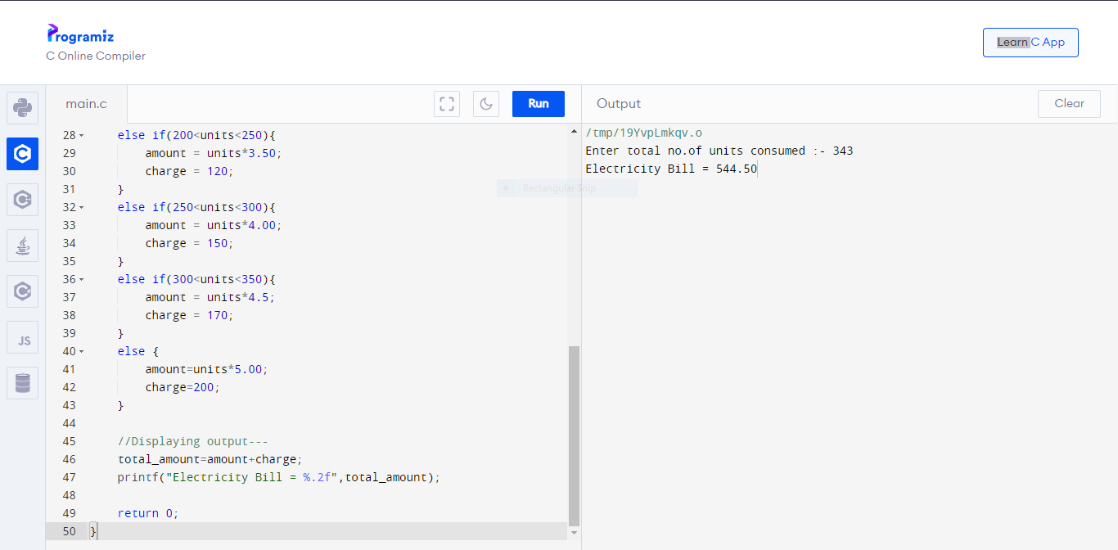

Sample 2

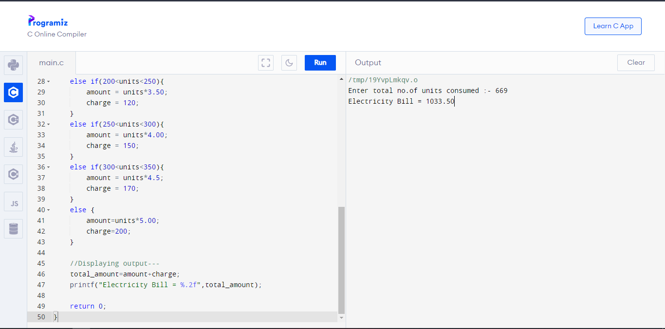

Sample 3

